**PROJECT PROFILE**

|  |  |
| --- | --- |
| **Project Name** | Chardeyal.com |
| **Objective** | This web application will manage library management system. Generally, in a university, students go to library, search book from catalog access and take note the location then go to librarian desk and borrow books .Since these types of work need paper work and is very error prone, we are offering this application to process it automatically from their site. Following are the stories for the mentioned application.  . |
| **Platform** | Website |
| **Front End** | Angular JS , Bootstrap, CSS3,HTML |
| **Back End** | C# Dot Net Microsoft SQL Server 2014, OData Service |
| **Project Duration** | 30days |

**Projects Details**

1. Application will provide the support of search book, loan books and return books.

**2. Property types are:**

* Books
* Authors,
* Publications,
* Categories

3. To search a book must sign up to application as a user (Property Owner). He must provide user ID and password to register. Also can register with Gmail ID and Facebook. User must provide Name, Address, Phone Number, email address.

4. To issue book one must register to the application as a user (Property Renter).He must provide user ID and password to register. Also can register with Gmail ID and Facebook. User must provide Name, Address, Phone Number, email address.

**###Books must have:**

* Book name
* =>Category Name
* No of book
* No of loan copy
* =>Author Name
* =>Price
* Publication Name
* Issue date
* Due Date

**### Author must have:**

* Author name

**### Publication must have:**

* Publication name

**### Category must have:**

* Category name

**FUNCTIONAL SPECIFICATIONS**

**USER SPESIFICATION**

**Librarian:**

* approve user ,
* delete user,
* get report from anonymous
* delete book
* Change password.
* Issue Book,
* Return Book
* Lost copy Book,
* Stock update
* Report generate

**Student:**

* login/logout
* Search Book
* Loan Book,
* Use profile,
* Request Book

**Teacher:**

* login/logout
* Search Book
* Loan Book,
* Use profile,
* Request Book

**SOFTWARE REQUIREMENT**

**Client side:**

**Web Browser** Internet Explorer 6 or any compatible browser.

**Operating System** Windows or any equivalent OS

**Server side:**

**Web Server** IIS 7.5

**Framework** .NET 4.5 with C#

**Database Server** MS SQL Server 2014

**Web Browser** Any Compatible browser

**Operating System** Windows Server 2010

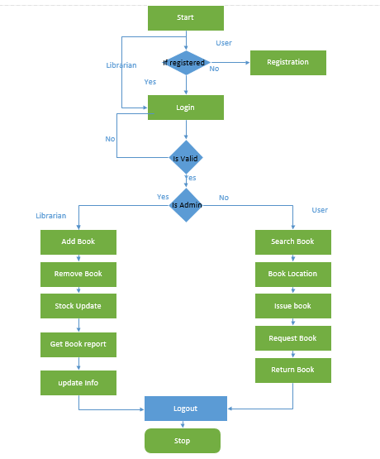**System Flow Chart**

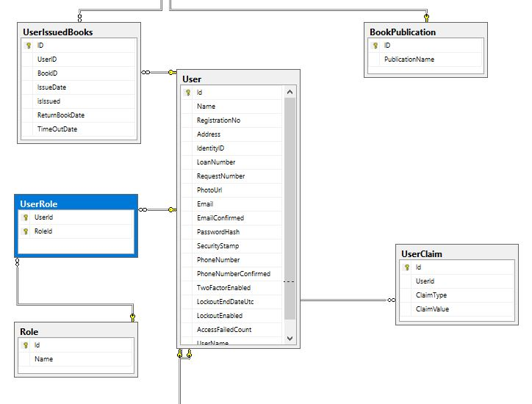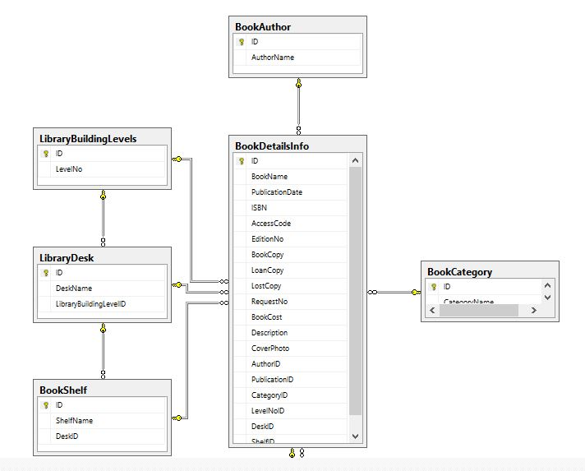**E-R Diagram**

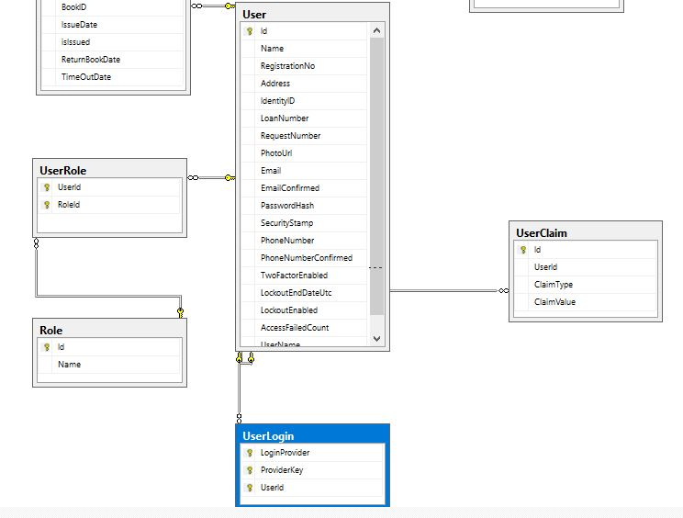

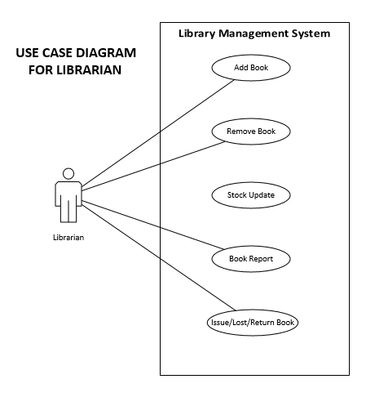**Use Case Diagram for Librarian**

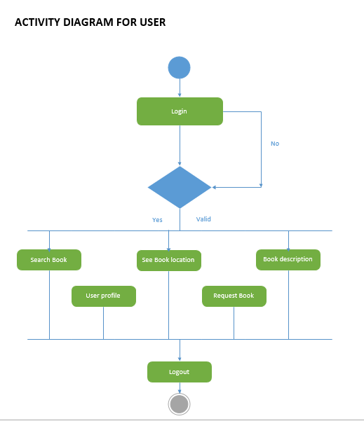**Activity Diagram for User**

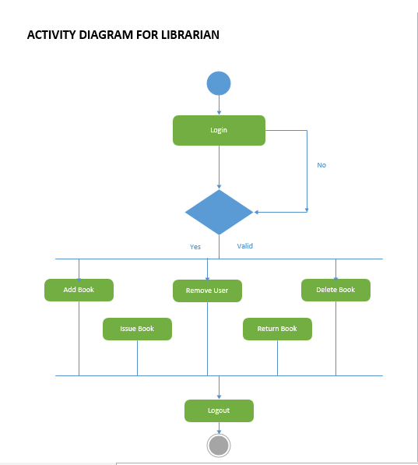**Activity Diagram for Librarian**

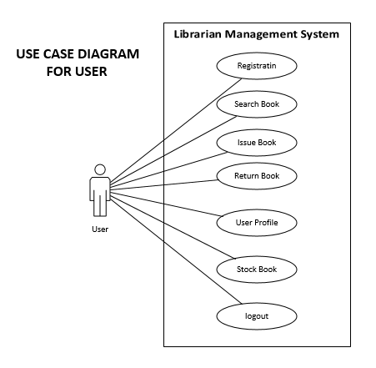**Use Case Diagram for User**

**Class Diagram**

**SEQUENCE DIAGRAM FOR LIBRARIAN**

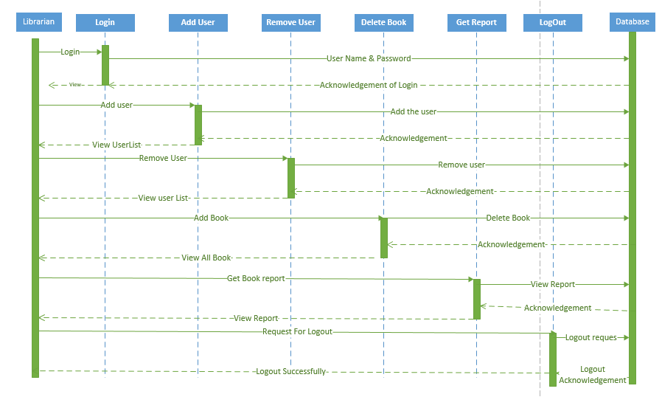

**SEQUENCE DIAGRAM FOR USER**

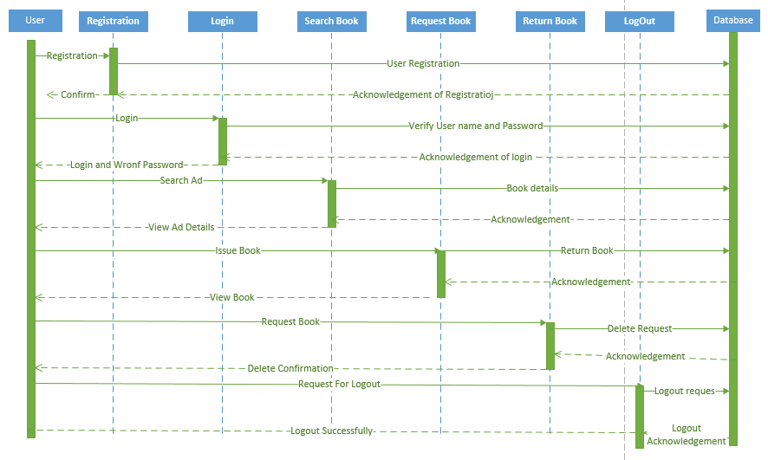

**DATA DICTIONARY**

|  |
| --- |
| **Table** **No:1 User** |
| User_Id (PK) |
| Name |
| Email |
| Password |
| Address |
| Phone Number |

|  |
| --- |
| **Table** **No:2 User_Role** |
| User_Id (FK 1) |
| Role |

|  |
| --- |
| **Table** **No:3 Author** |
| City_Id (PK) |
| AuthorName |

|  |
| --- |
| **Table** **No:4 Publication** |
| Location_Id (PK) |
| PublicationName |

|  |
| --- |
| **Table** **No:5 Library Building Level** |
| Property_Id (PK) |
| LevelNo |

|  |
| --- |
| **Table** **No:6 Desk** |
| Desk_Id (PK) |
| DeskName |
| LevelID |

|  |
| --- |
| **Table** **No:7 Book** |
| ID |
| BookName |
| AuthorId(FK) |
| PublicationID(Fk) |
| CategoryID(FK) |
| BookCopy |
| Is Issued |

|  |
| --- |
| **Table** **No:8 Shelf** |
| ID |
| ShelfName |
| DeskID |

**Home Page:**

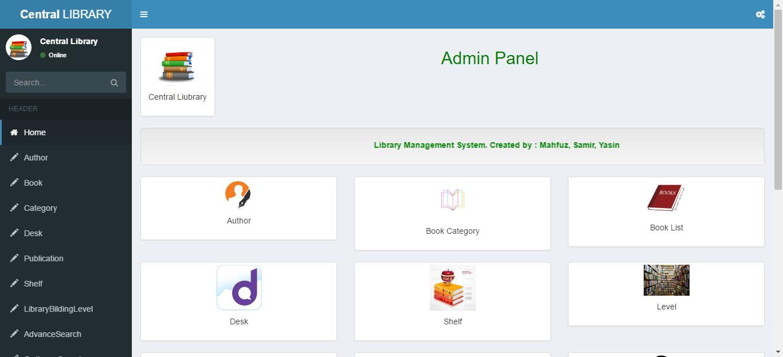

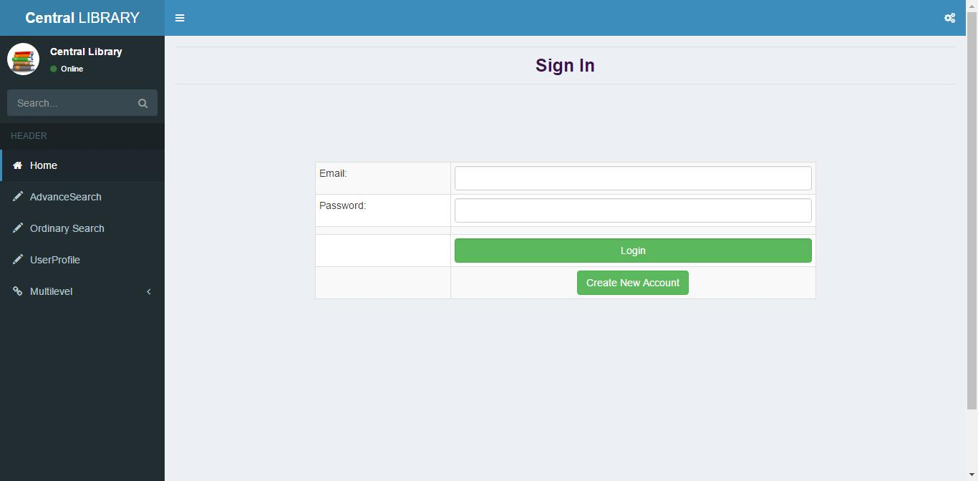**Login & Registration:**

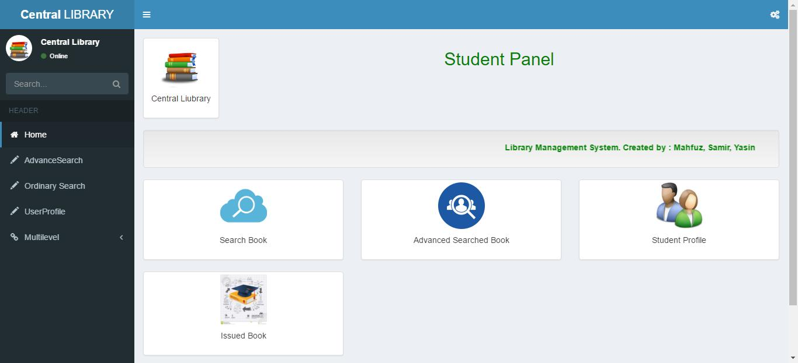**Student Dashboard:**

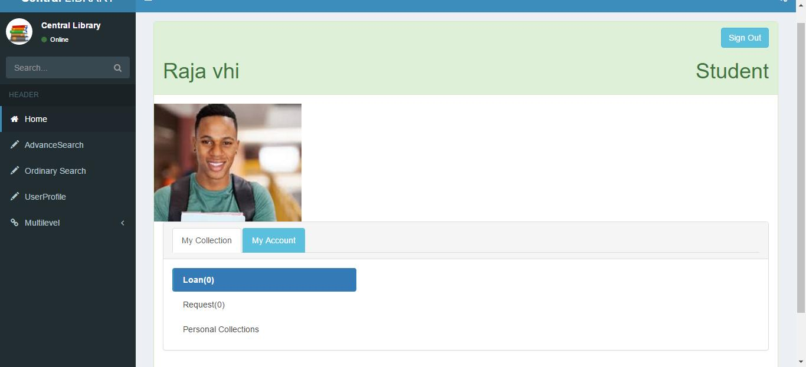**User Profile:**

**Search Book:**

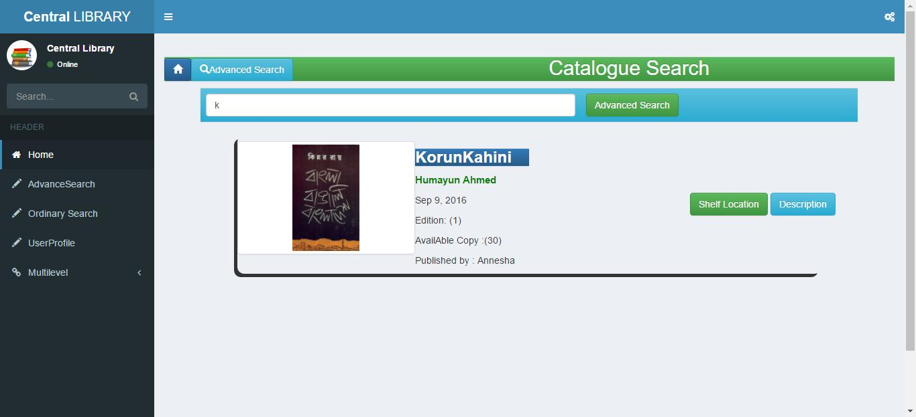

**Issue Book:**

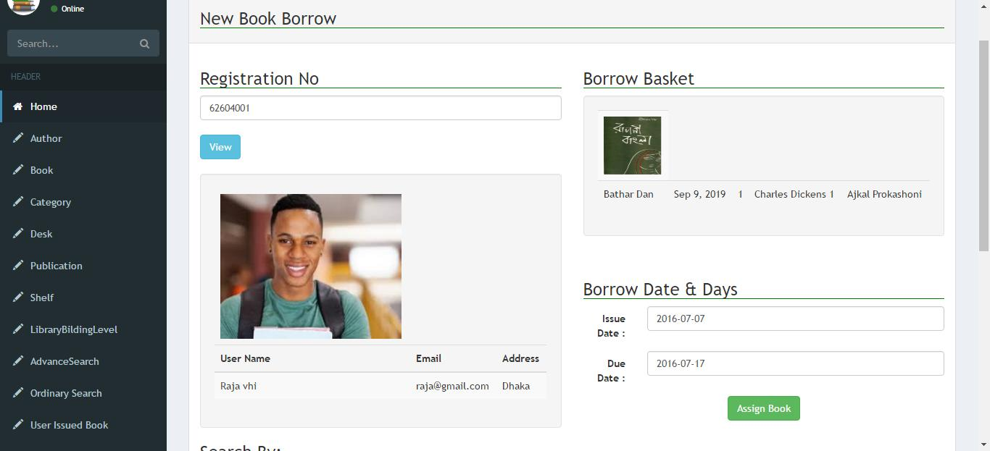

**Return Book:**

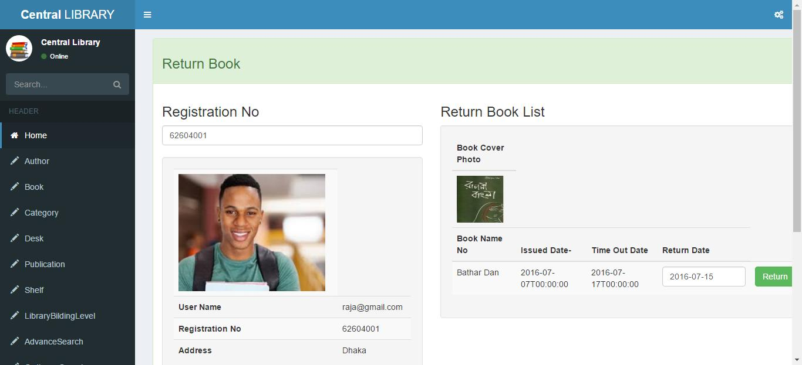

**Stock Update:**

